Rubric Graded by Teacher for Debate Performance (40 points)
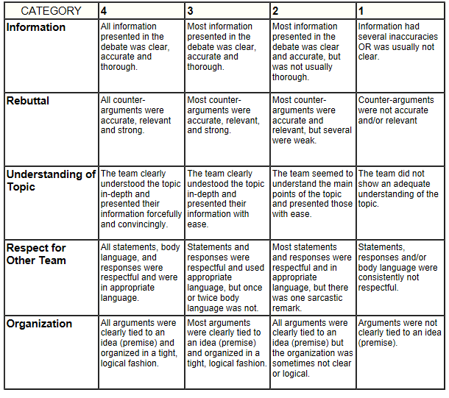

Rubric Graded by Group Members (combined total of 20 points)
